CONTENTS

- Abstract 3
- Introduction 5-6
- System Analysis 7-10
  - Objectives of System
  - User Requirements
  - Hardware And Software Requirements
- Software Design
  - UML Diagrams
    - Use Case Diagrams
    - Activity Diagrams
    - Class Diagrams
    - Sequence Diagrams
- Database Design
- Input and Output Screens
- Conclusion
- Bibliography

ABSTRACT

Description:
The aim of the study was to develop a World Wide Web-based course feedback system serving both students and teachers. The system includes generation and analysis of course feedback pages, provision of feedback, and a summary. Student feedback system is developed for the engineering college students. Students give opinion about their faculty members and vice versa.
The purpose of this feedback system is to gather information on learning experience as well as the about lecturer(s) performance in the class. Student after login into the system, then only is possible to give feedback He has to login with registration number not with the name. He will give the feedback to the faculty member by subject wise. He has five options Excellent, Very good etc. and student has to select one of the five options about faculty in his feedback form. There is a different areas he has to cover individually while giving the feedback like voice strength, Teaching style, Subject knowledge, Behavior and Timing sense. Then He has to submit his feedback with the system. Student can view the Semester results in this system.
Administrator module to avail the facilities college has to register with the system. College user has to append details of the courses offering and branches (EEE, CSE etc). College has to provide Branch name, Branch Code, Course Name and no of Seats. College has to add Faculty members by subject wise, and his/ her full Contact details. They can view details of subjects by branch, Course, Year, Semester and
regulation wise. College has to register the students in bulk then they will divide into sections. Student can view the details of results in way of promotion and demotion.

Features:
- This system is developed mainly for the purpose of students to give their feed back about their teachers
- Student can view his/her semester results and grades in this system.
- This system is developed for the exclusively for the engineering colleges students and lecturers.
- Student has to register as a group with a system , it will not accept if student registered individually.
- College can register with the system with branch and faculty details.
- Student has to login with the number not with the name.

INTRODUCTION:

Student feedback system is developed for the exclusively for the purpose of students and lectures. In this system students can view their results semester wise. The purpose of this feedback questionnaire is to gather information on your learning experience, as well as your response(s). When clicking the answer, you have to think of these questions as your subjective perceptions on various aspects of the course and the teacher(s) involved in the program.
The opinion or information provided by the students is useful for the teacher(s) as well as the University in the ongoing efforts and enhance the quality of education. The opinion provided by the student will be kept confidential. The evolution will be calculated on the basis of total scores from the responses from all students. Student(s) has to mention only his register number, need not to mention his name. Student(s) will give their opinion voice strength, teaching style, subject knowledge, and behavior and timing sense. He has select one option from five options (excellent, very good, good, satisfactory, not satisfactory) and also he has to mention faculty name, subject, branch, and department. This information has to submit with the system.
In admin module only college has to register with the system. College has to add branches with the code number and course name. College has to register faculty members with respected course and Department and their total personal details. University or College has to add subject details in particular branch with syllabus. Registered faculty members are appointed to the respective branches. They have to add feedback questions to the system. College has to register in a bulk, and then they have to segregate as groups and allotted sections to them.

Details of Promoted students to next semester will be kept on system. They can view by student id, course name, branch name, section and year. Feedback will be shown in charts and bars format. Then assessment details can be viewed branch, section, course and year. It will give information about faculty members; they have to improve their performance or vice versa will be notified.

Features:
- It is useful to analyze the performance of the faculty members in engineering college.
- Students can view their results, attendance by branch wise and id number.
- Students will give their review about the faculty members in a questionnaire
- Lecturer(s) appointed to the respective departments, with their experience and qualification.
- Administrator will introduce the new colleges to the students and lecturers.

SYSTEM:
- Designing and implementing the new links.
- Designing and implementing the users.
- Arranging new links as subject wise.

SYSTEM ANALYSIS:
System analysis will be performed to determine if it is feasible to design information based on policies and plans of the organization and on user requirements and to eliminate the weaknesses of the present system.
- The new system should be cost effective.
- To expand management, improve productivity and services.
- To enhance user / system interface.
- To improve information quality and usability.
- To upgrade systems reliability, availability, flexibility and growth potential.

3.1 Objective of the System:
The main objective of the system is that to provide quality education with proper resources to the students in a reasonable expenditure. Improve the quality of education and also improve the lab facilities, teaching qualities, classroom facilities and other facilities for the students. Main aim is that make available results online for the students they can available 24/7 for the students.

Objectives:-
- The System is composed with convenient modules of setting and editing the convenient modules for the students to give their opinions about the lecturers and know about the college details.
- Modules are designed user friendly they can reach anywhere directly without any confusion.
- This system is designed to save the time and reduce the paper work for taking opinions and making assessments.
- Administrator will introduce the new colleges to the students to increase the options to the students while joining / selecting the colleges.
- To improve the quality of education considering the opinions of students.
3.2 User Requirements:
- User has to register with the system for using all the facilities available in the system
- Student User has to submit his opinion about his faculty by course, name, subject and department / branch wise.
- Student can view his results semester wise, it will give the information he/she has promoted/ demoted in the examinations.
- Student has to login with his id number, which is assigned by the system.
- College user has to provide details of total number of student, faculty members and contact information.
- User can view the assessment details by way of charts and bar diagrams and providing course name, branch name, year etc.

- This system runs any platform; user can access the student id from any place.

3.3 HARDWARE & SOFTWARE SPECIFICATIONS:

HARDWARE REQUIREMENTS:

Processor : Intel P-IV system
Processor Speed : 250MHz to 833MHz
RAM : 512MB RAM
Hard Disk : 40GB

SOFTWARE REQUIREMENTS:
Operating System : Windows XP
Database : Sql Server
Server side technology : ASP.Net
Server side scripting : ASP
Client side scripting : HTML
Web-Server : IIS

4.1 UML DIAGRAMS

UML Diagrams

4.1.1 USE CASE DIAGRAM:
- A use case diagram is a diagram that shows a set of use cases and actors and relationships.
Contents
- Use case commonly contain
- Use cases
- Actors
- Dependency, generalization and association relationships

Overall Use Case

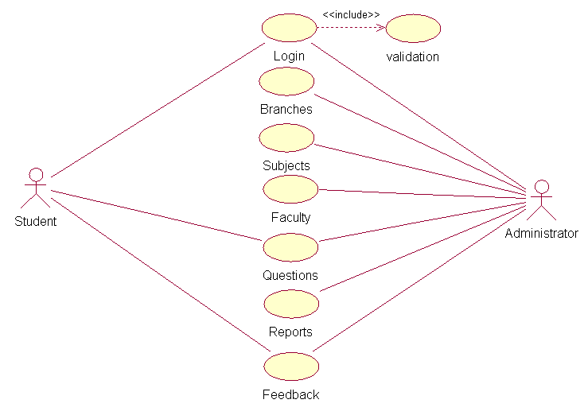

Administrator Use Case

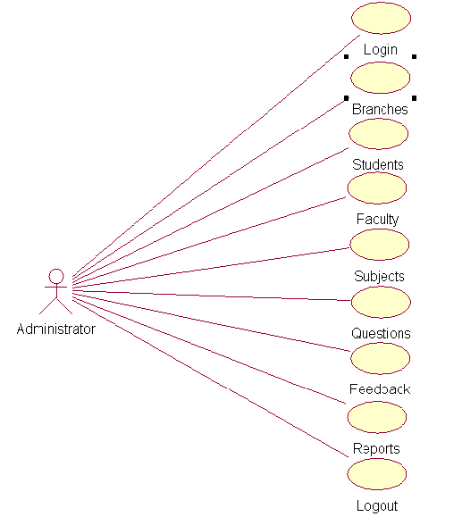

Student Use Case

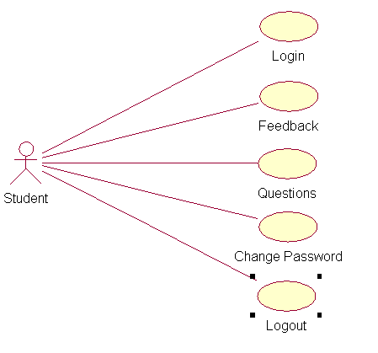

Class Diagram

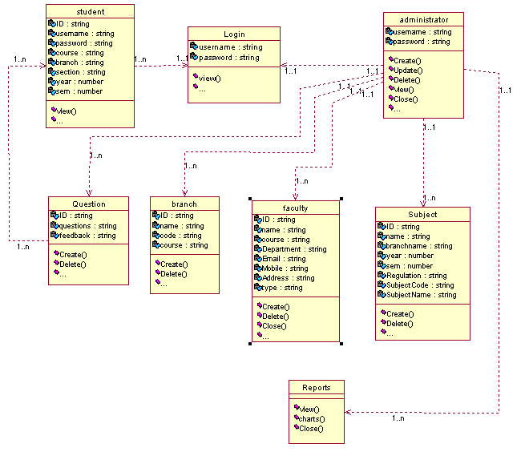

4.1.2 ACTIVITY DIAGRAM:

- An activity diagram shows the flow from activity to activity. An activity is an ongoing non- atomic execution within a state machine.
- Activities ultimately result in some action, which is made up of executable atomic computations that result in a change in state of the system or the return of a value.
Activity diagrams commonly contain
- Activity states and action states
- Transitions
- Objects

  - Like all other diagrams, activity diagrams may contain notes and constrains.

Student Process
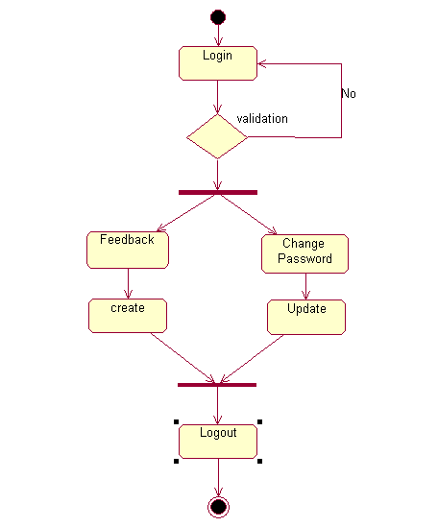
Administrator Process

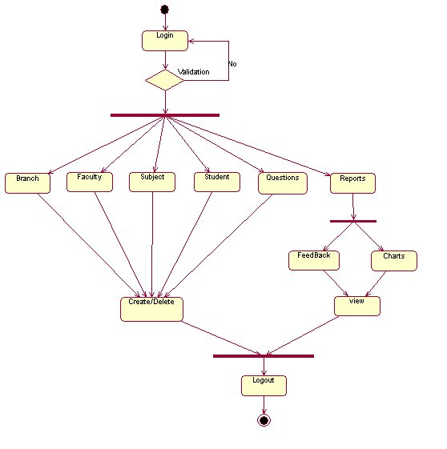

4.1.4 SEQUENCE DIAGRAM:

- An interaction diagram shows an interaction, consisting of a set of objects and their relationships, including the messages that may be dispatched among them.
- A sequence diagram is an interaction diagram that emphasizes the time ordering of messages.
- Graphically, a sequence diagram is a table that shows objects arranged along x-axis and messages, ordered in increasing time, along the y-axis.
Contents
- Sequence diagrams commonly contain the following:
    - Objects
    - Links
    - Messages
Like all other diagrams, sequence diagrams may contain notes and constrains.

Administrator Sequence

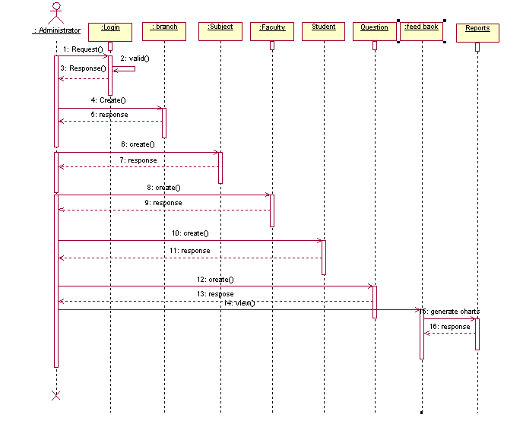

Student Sequence

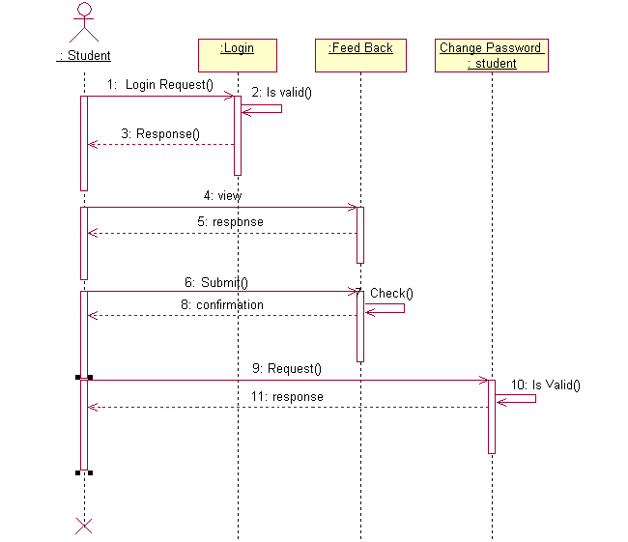

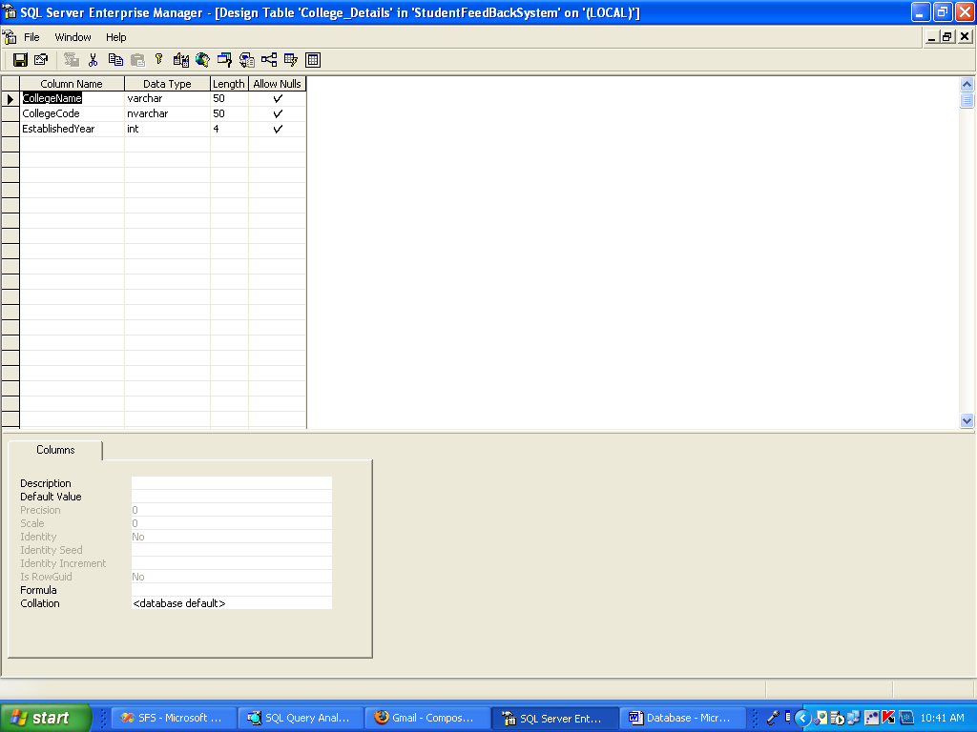

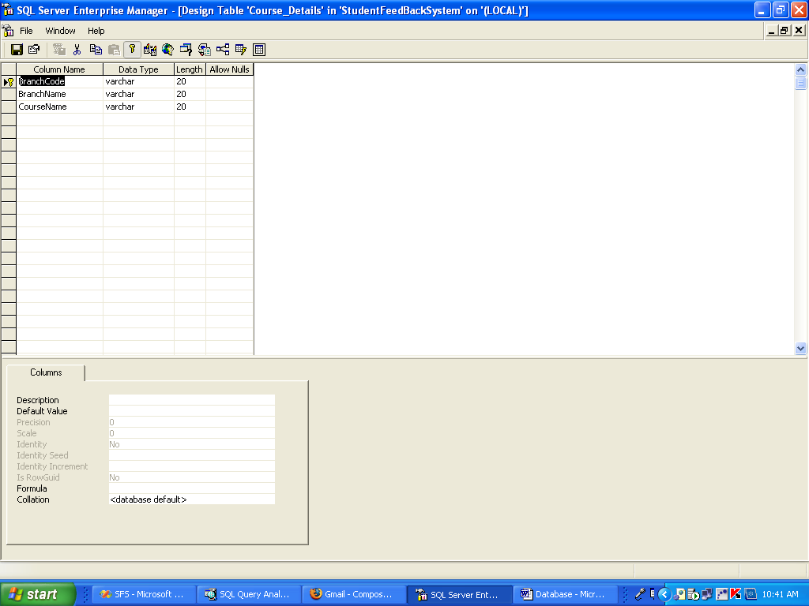

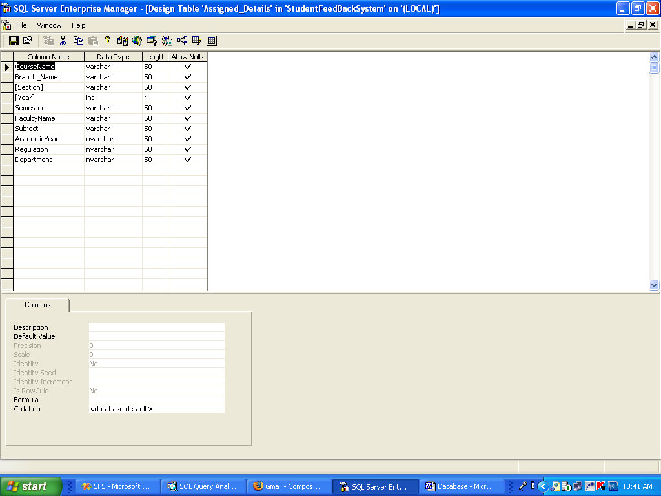

Faculty Details

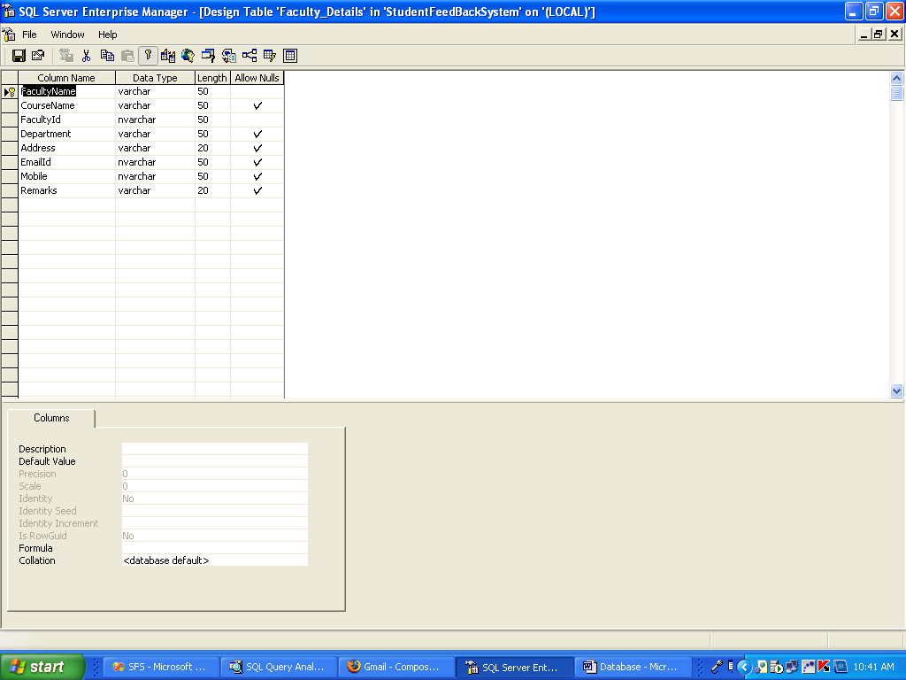

Feedback Details

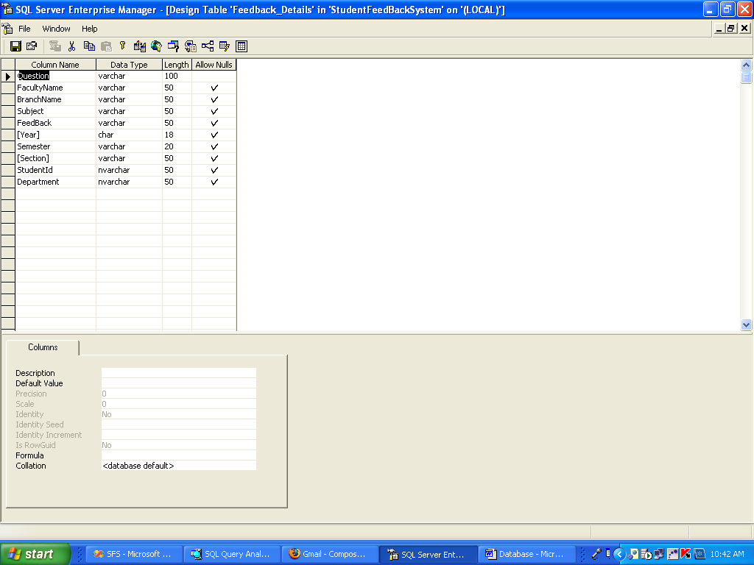

Question Details

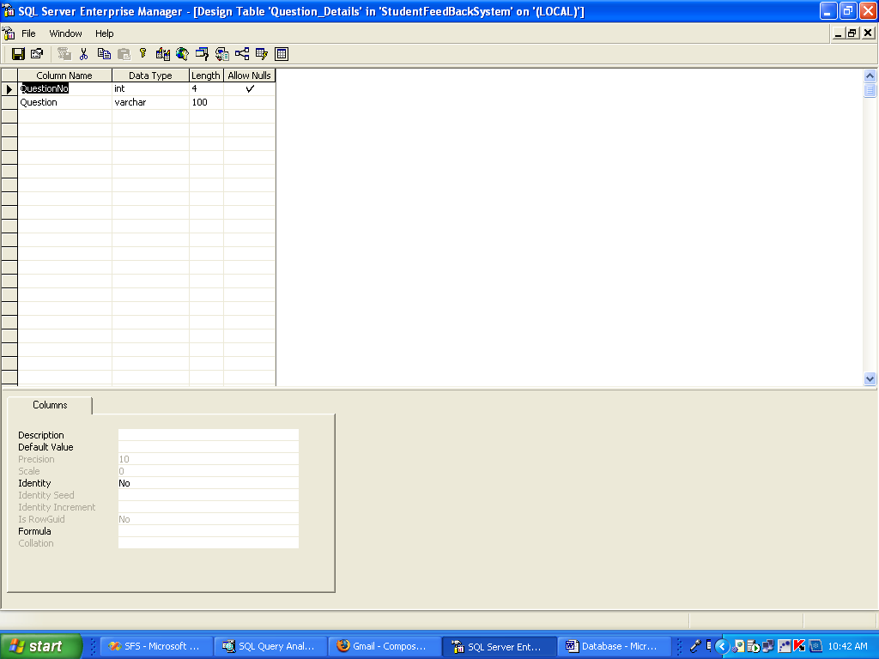

Student Details

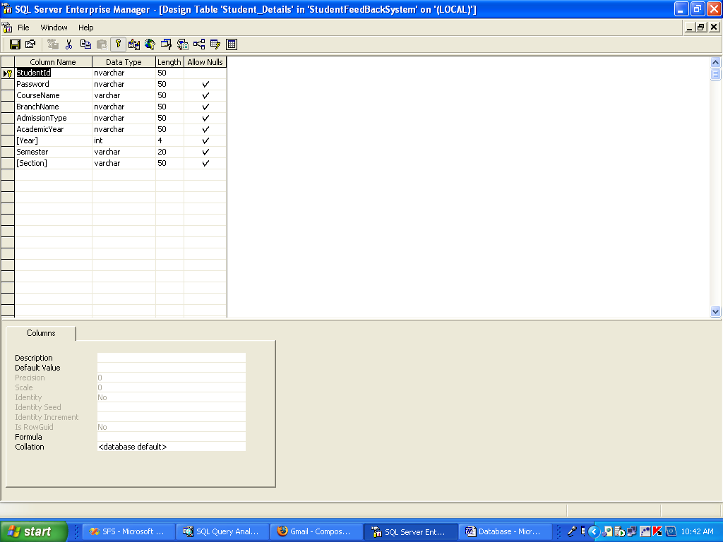

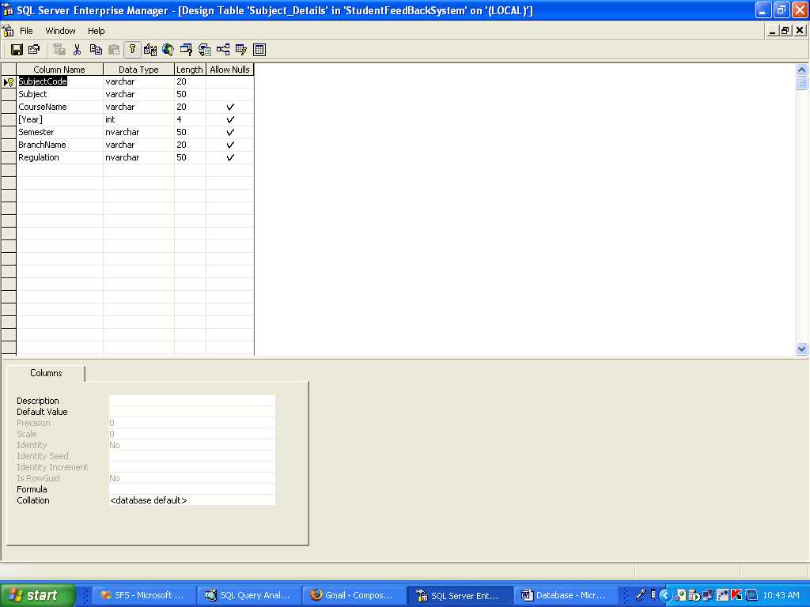

Student Module

Student Login Page

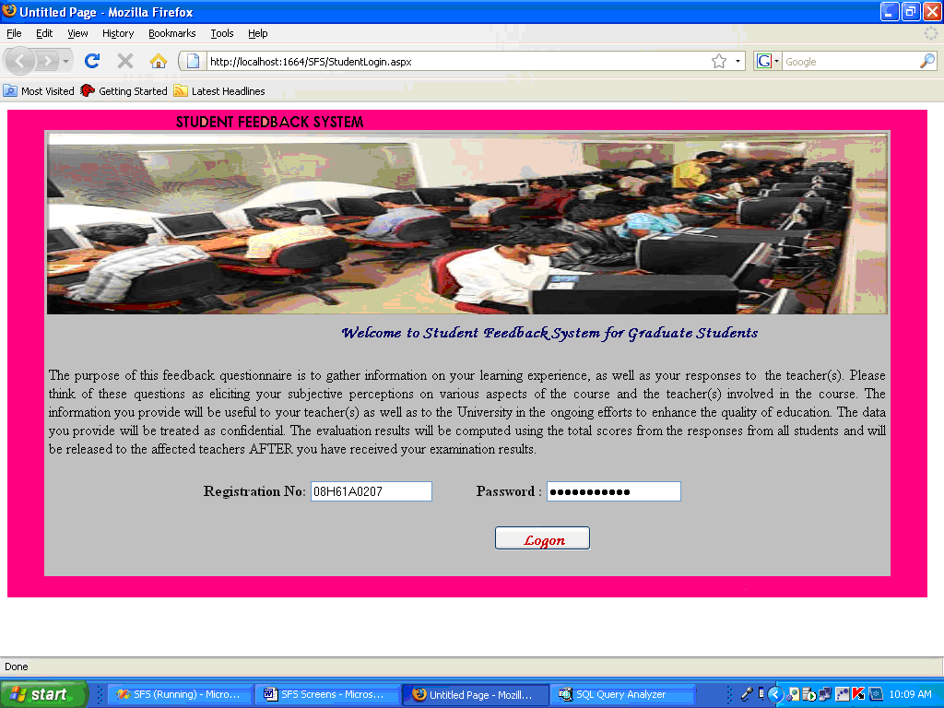

Feedback form

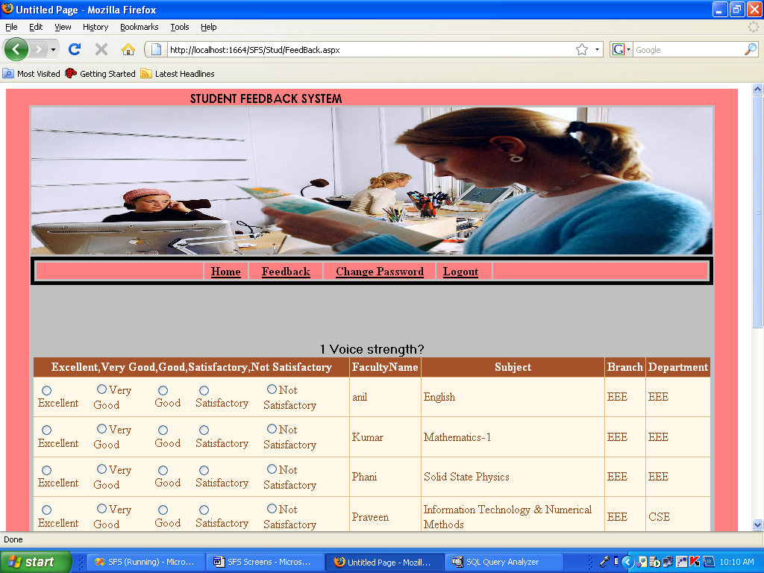

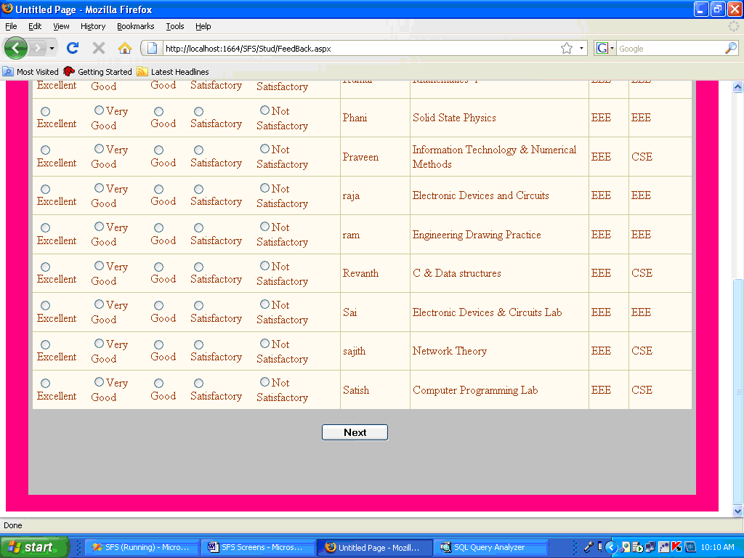

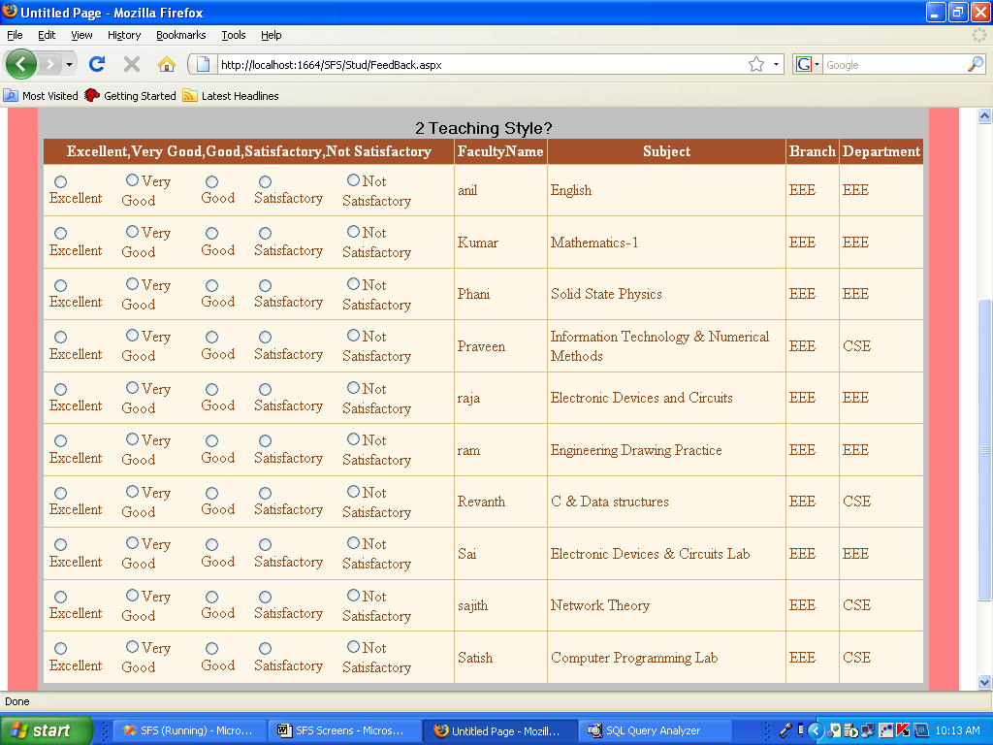

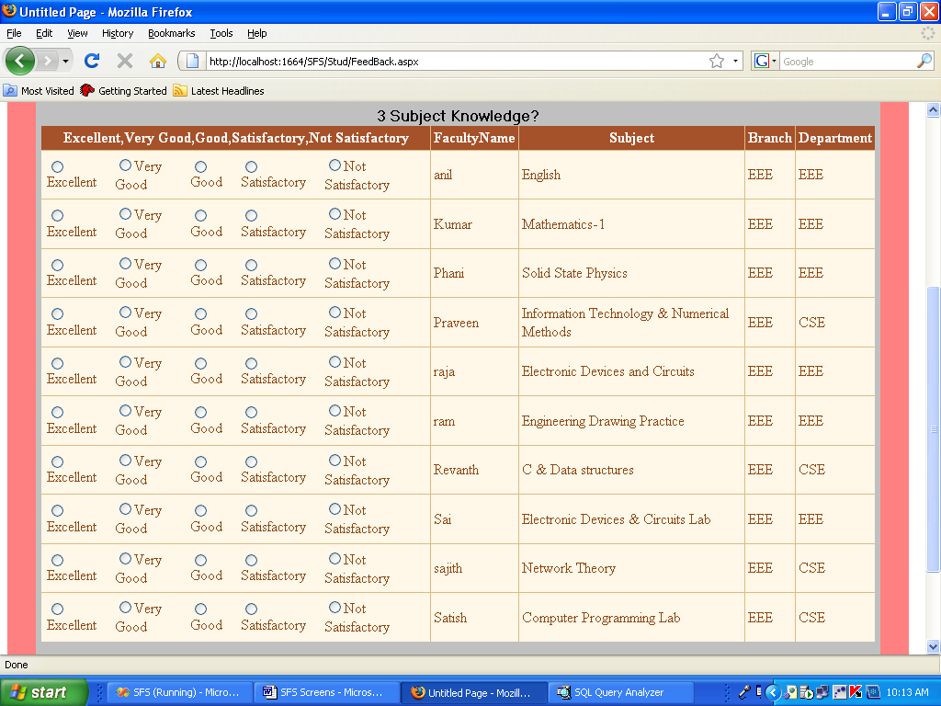

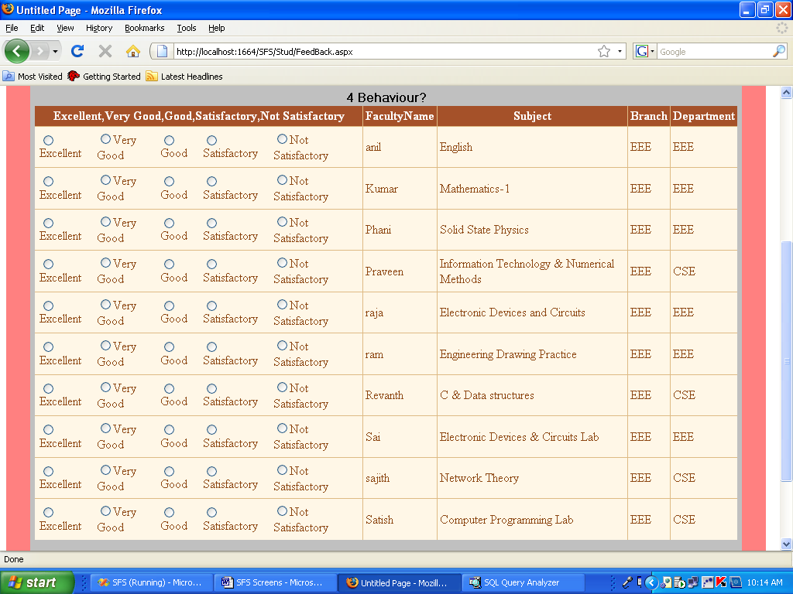

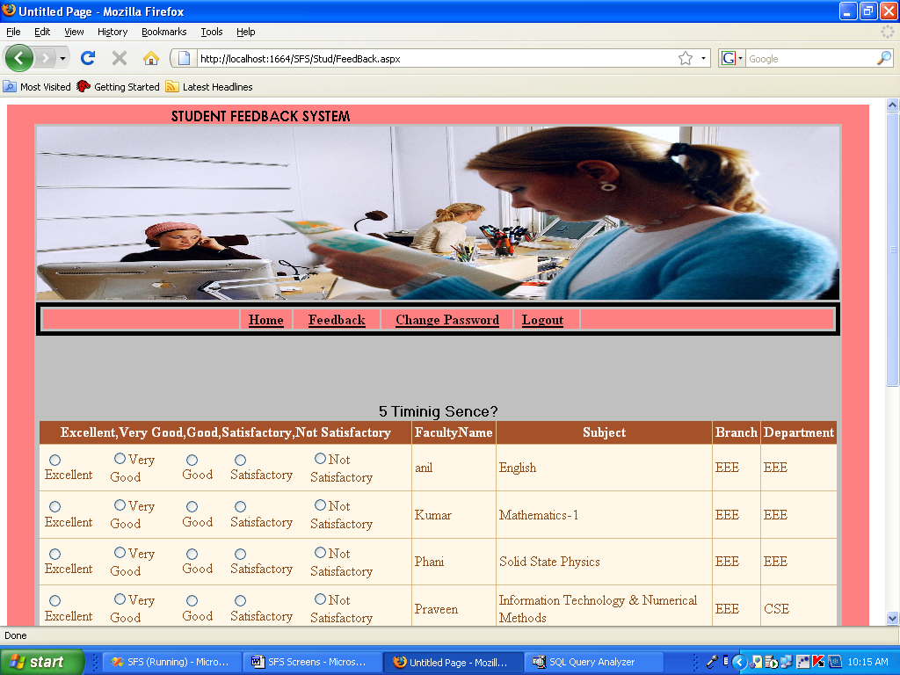

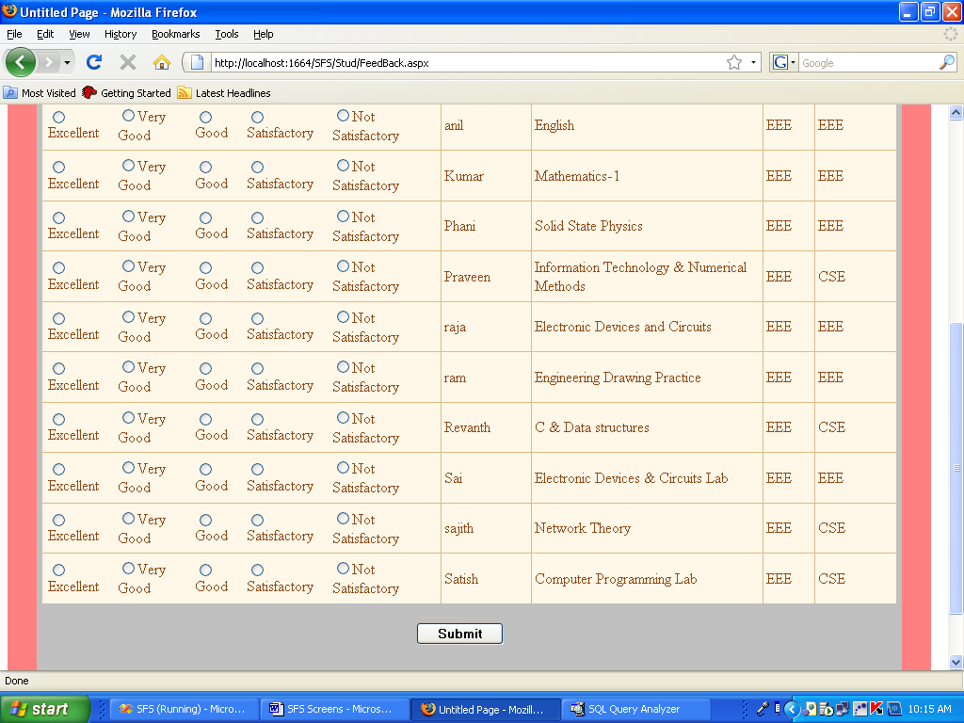

Feedback submitted

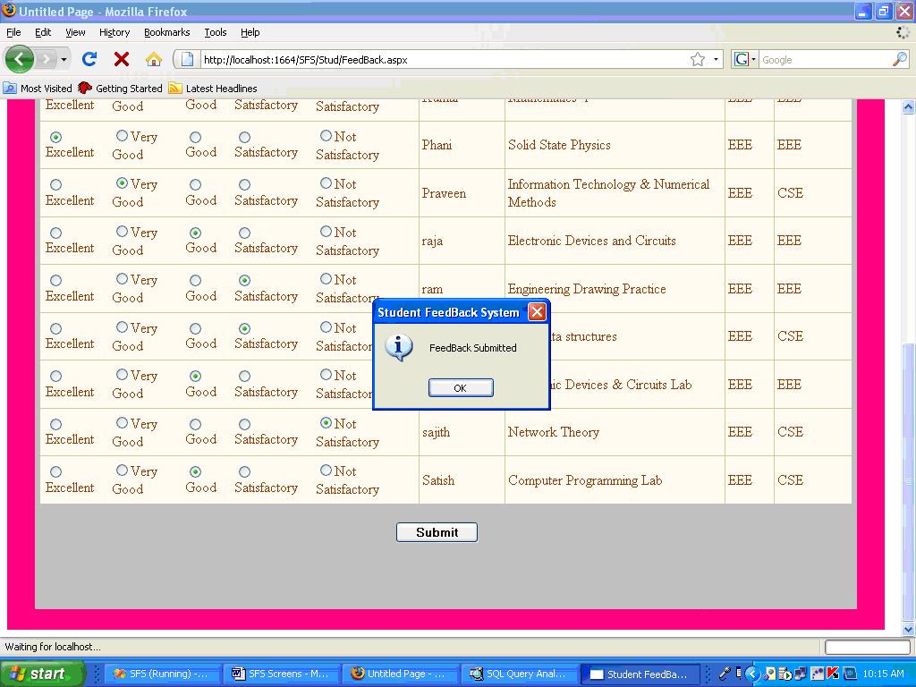

Feedback sent successfully

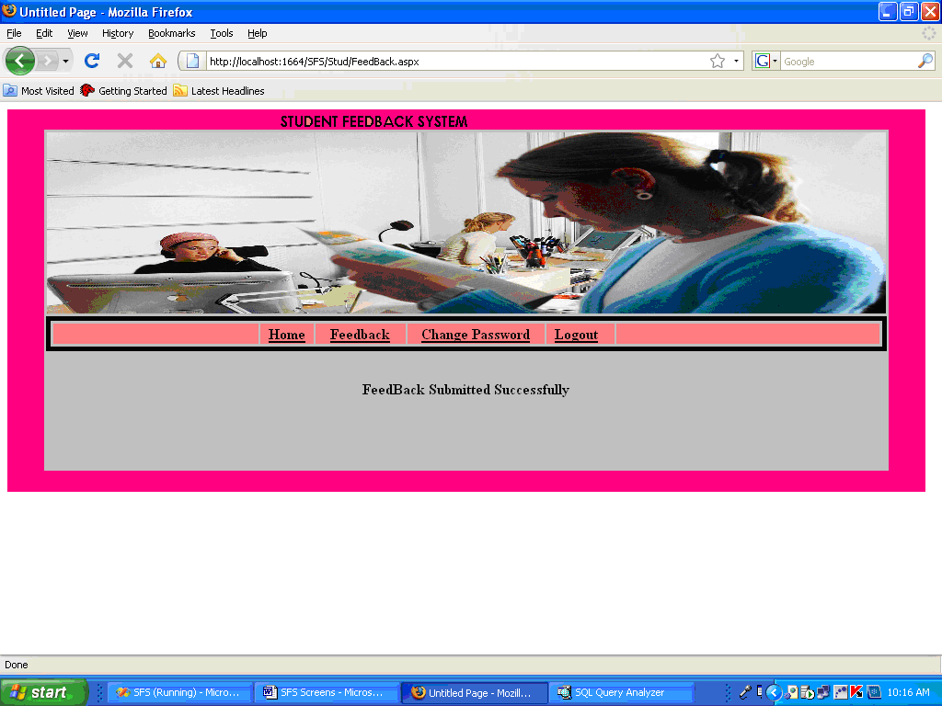

Change Password

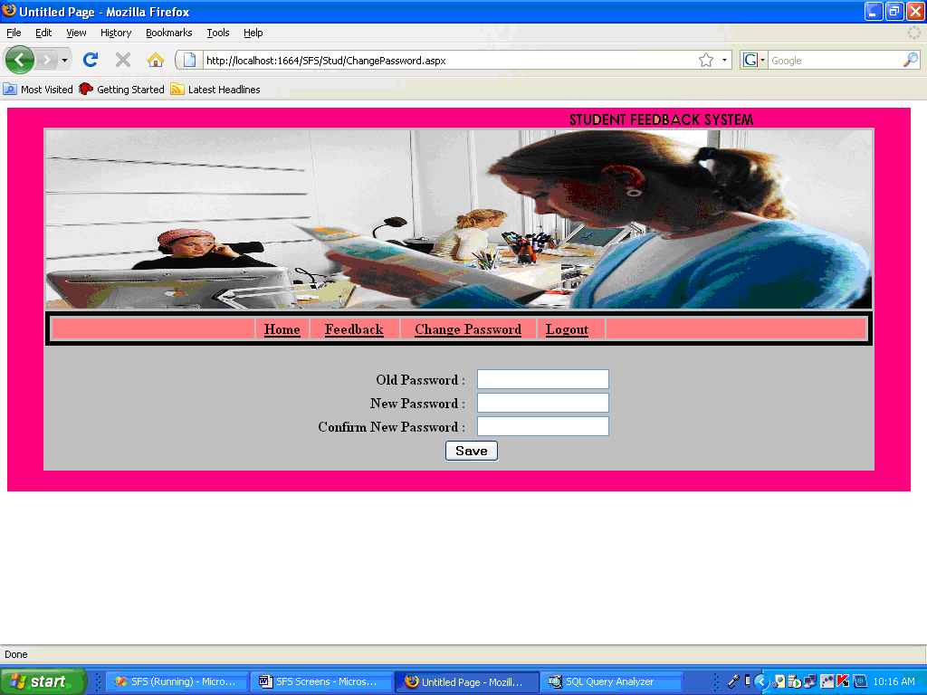

Administrator Module

College Registration

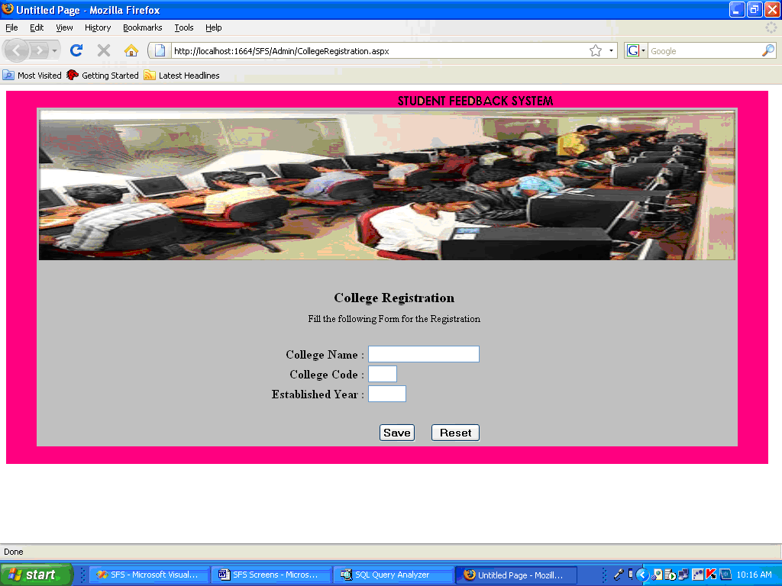

Admin_Login

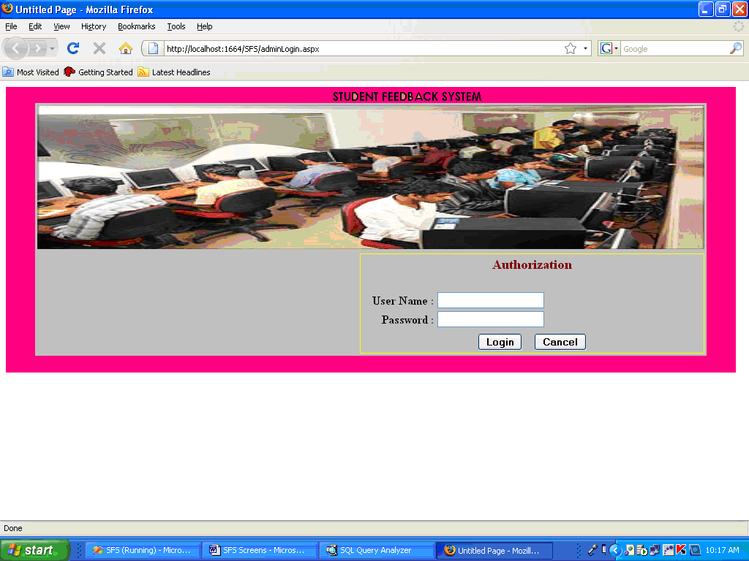

Adding Branches

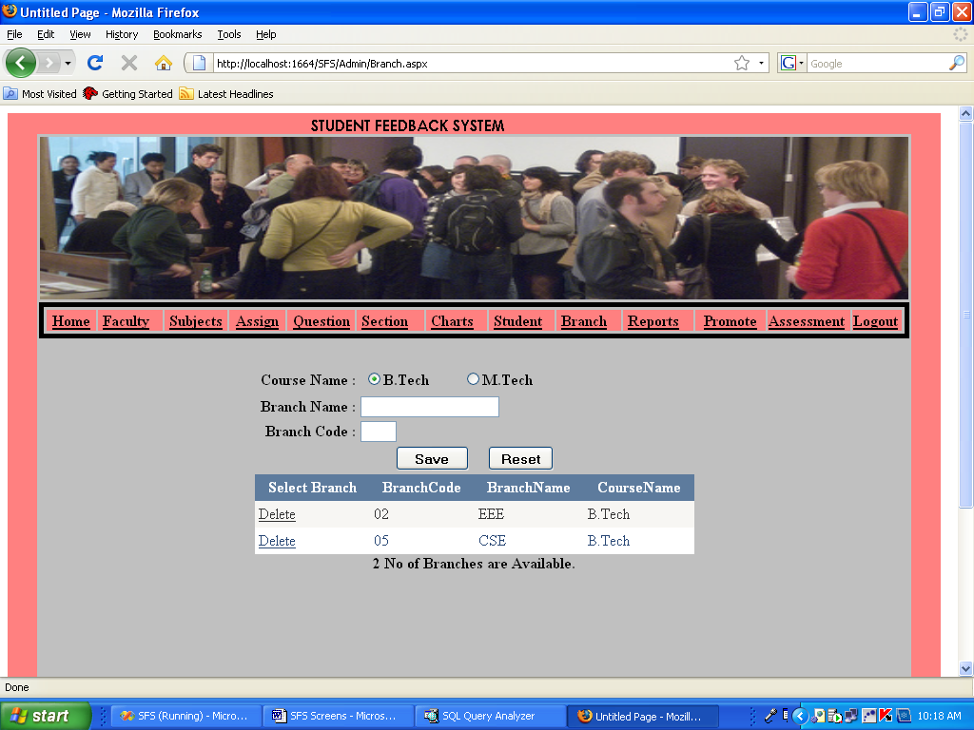

CONCLUSION
Normally conventional system we use maximum manual applications. It consumes lots of time and paper. But this system totally Web based, it means that student can enter into the system very easily. They can view the details of the colleges affiliated under JNTU University and their contact information. This system is totally user friendly and timesaving and cost effective system. All the modules are designed in a way that a layman can understand the system very easily. Student /college can reach the place where they want to reach in a very minimum amount of time.
Future enhancements:
- The complete project is to be web-based
- The student can view Results and assessment details online.
- All the services are provided in online
- College / Student user access the system staying anywhere

8. BIBLIOGRAPHY
The following books were referred during the analysis and execution phase of the project
SOFTWARE ENGINEERING
By Pete McBreen

COMPLETE HTML
By Matthew MacDonald

UNIFIED MODELING LANGUAGE
By Keng Siau, Terry Halpin

SQL FOR PROFESSIONALS
By Michael Otey

C#.NET Black Book
By Jimmy Nilsson

MSDN 2005
By Microsoft

